GDevelop Workshop

Setup
You can download GDevelop from https://gdevelop.io/download for Desktop or mobile, or run it in the browser https://editor.gdevelop.io/ lots of options!
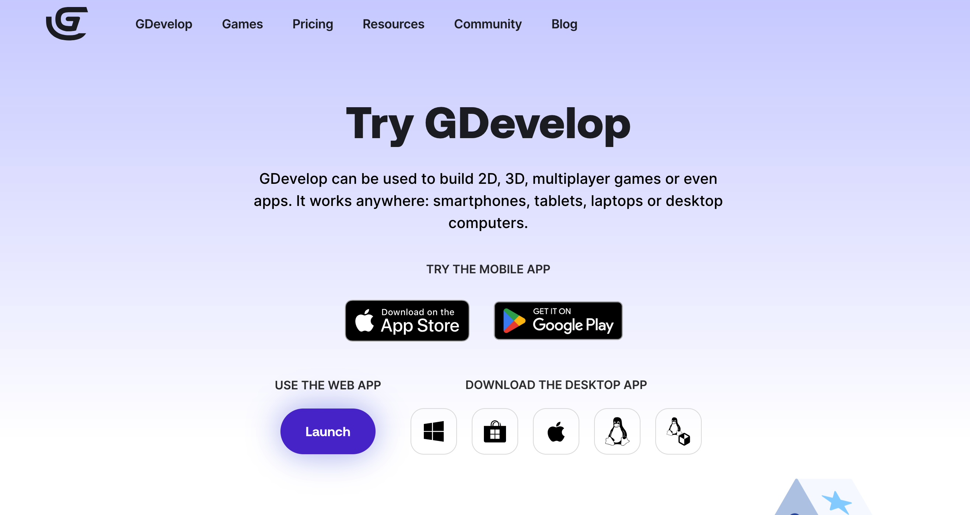
You’ll be greeted with a main screen 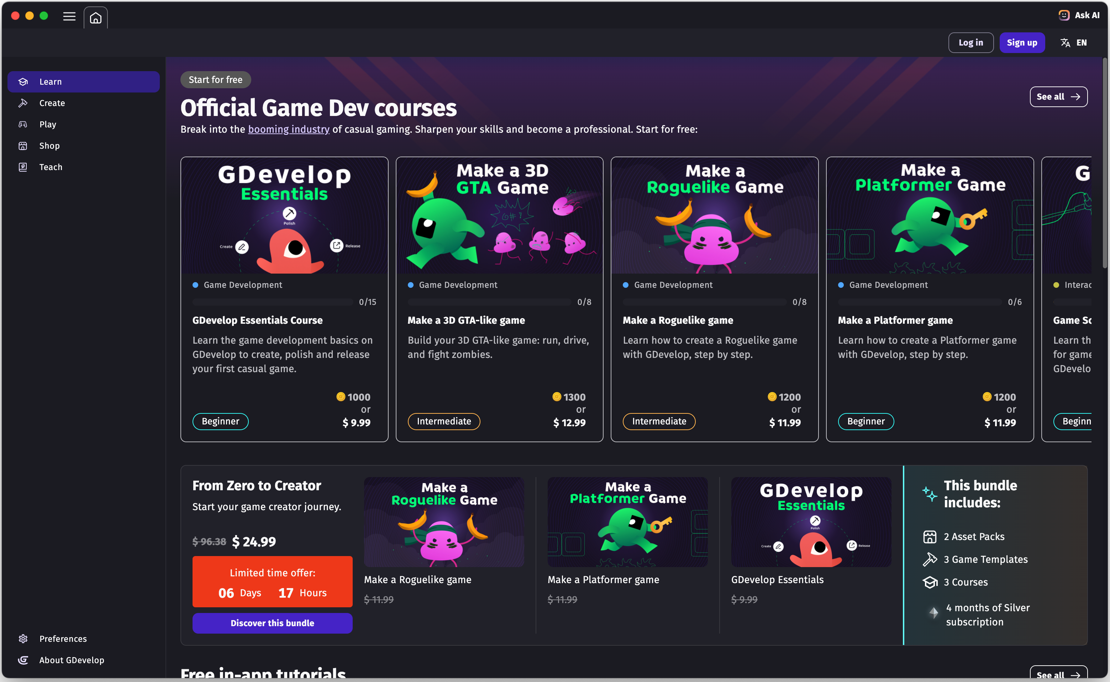

Create a Project
First, create a new project.
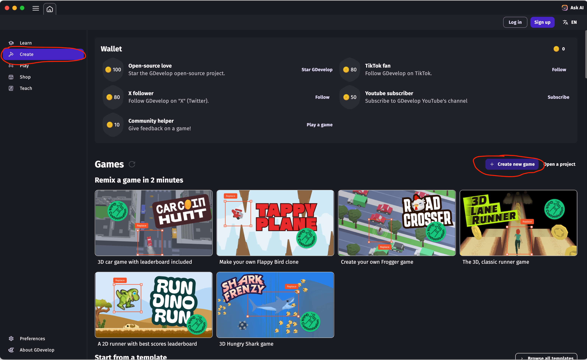
Select the “Platformer” template.
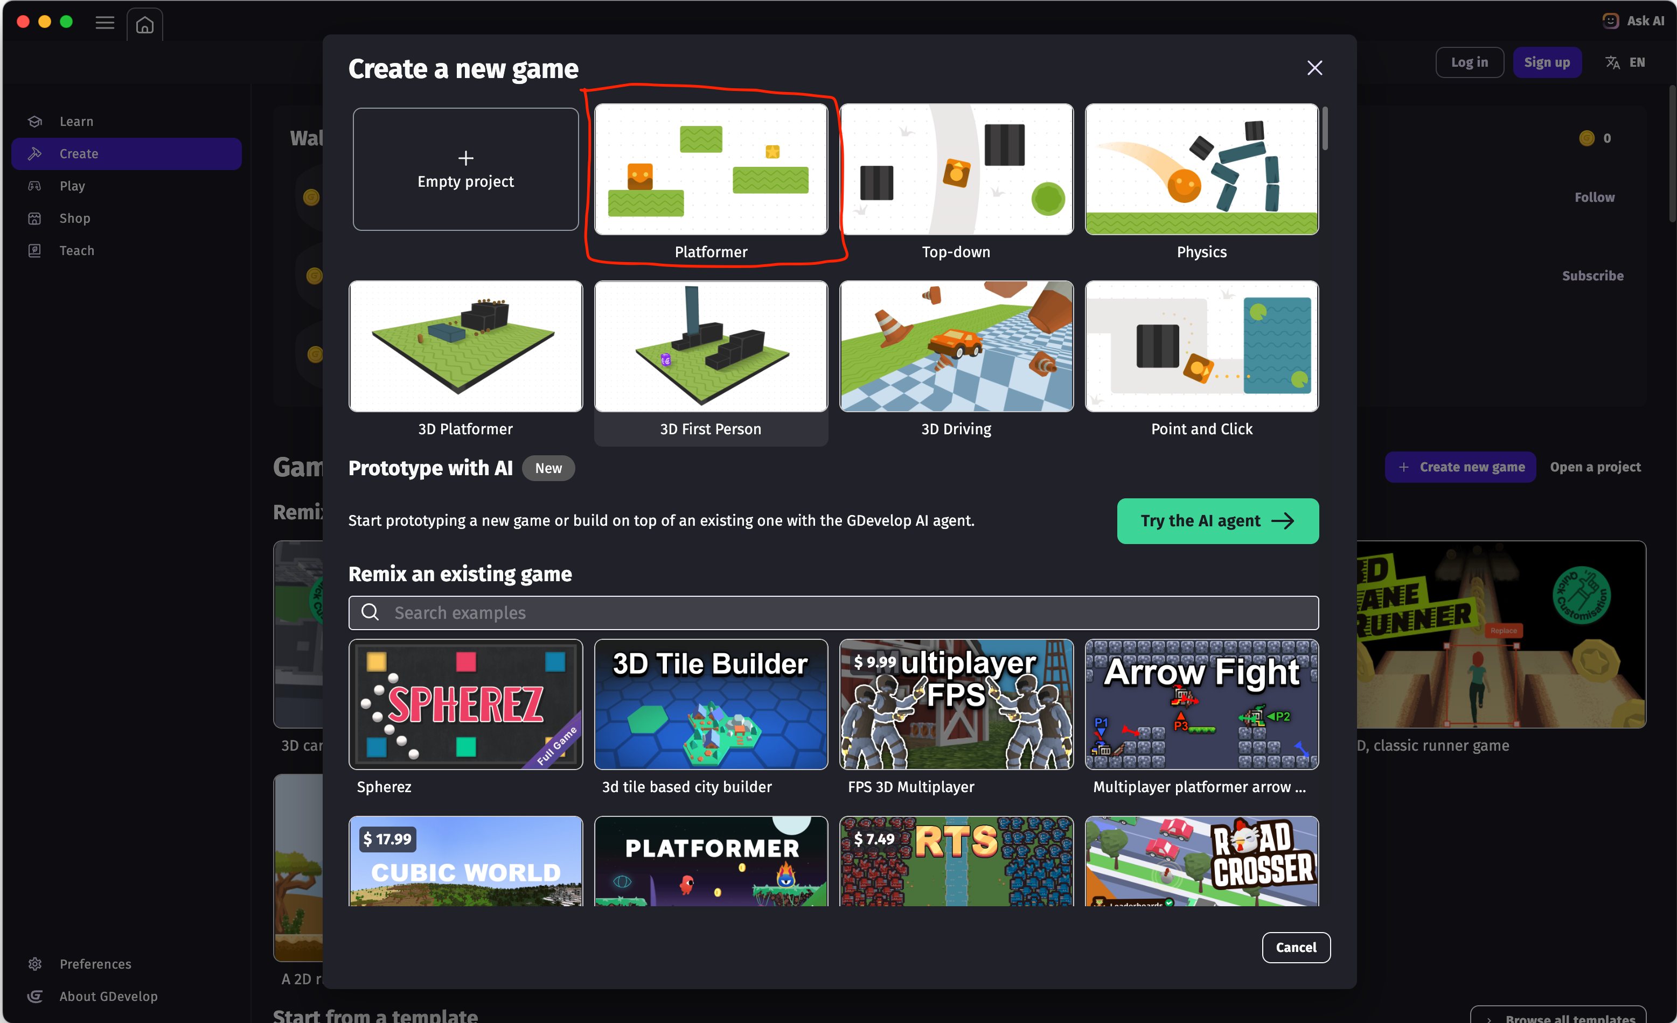
You can give it a name and save it to the cloud if you are logged in, or to your device.

Modify It!

Adding Coins
You can add extra coins by selecting one, and using copy and paste with the keyboard (Control/Command + C, Control/Command + V) and repeat with Command + V for each coin. You can also do the same with the platforms, including resizing them.
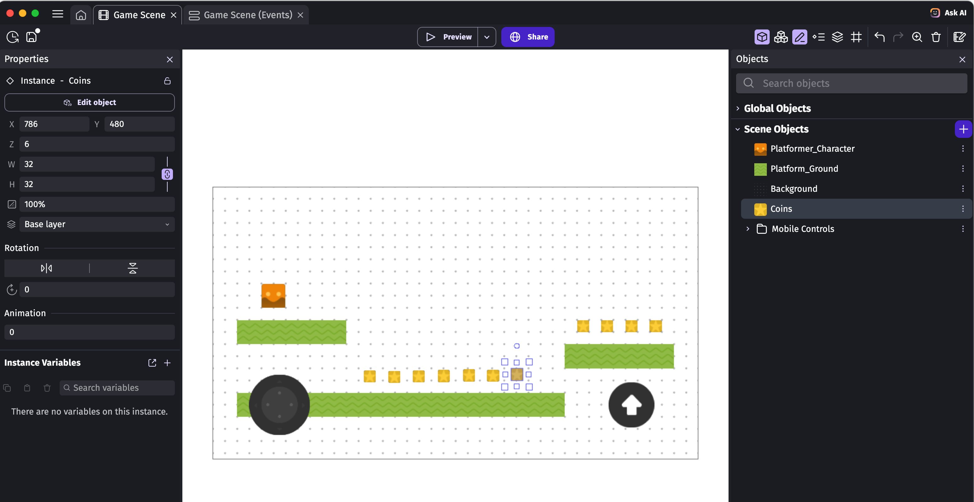

Fall off-screen
Now for some no-code coding! To detect if the player falls off screen, into the bottomless pit, we can add a condition that checks for that.
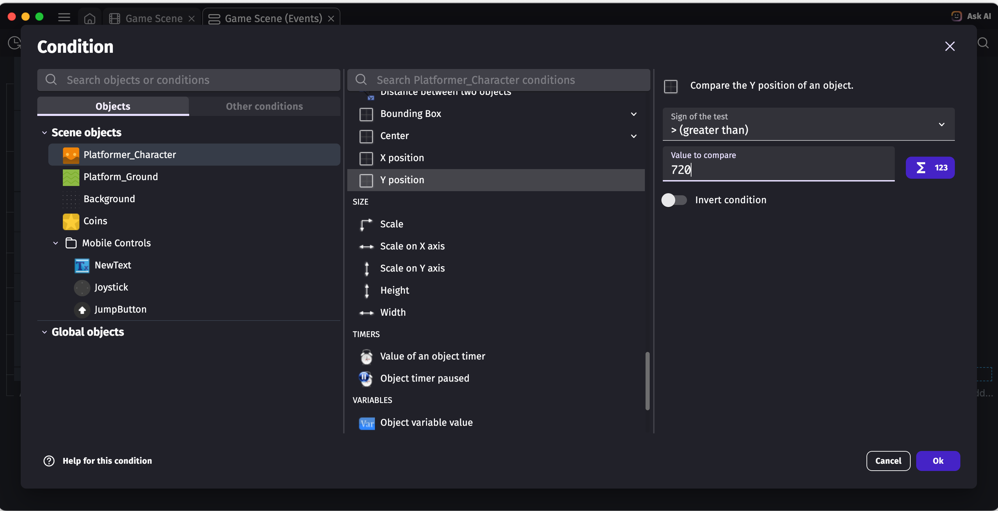

Fall off-screen (continued)
We want to save and recall where the player started at the beginning of the game. For another logic block we can add a condition that starts at the beginning of the scene or game.
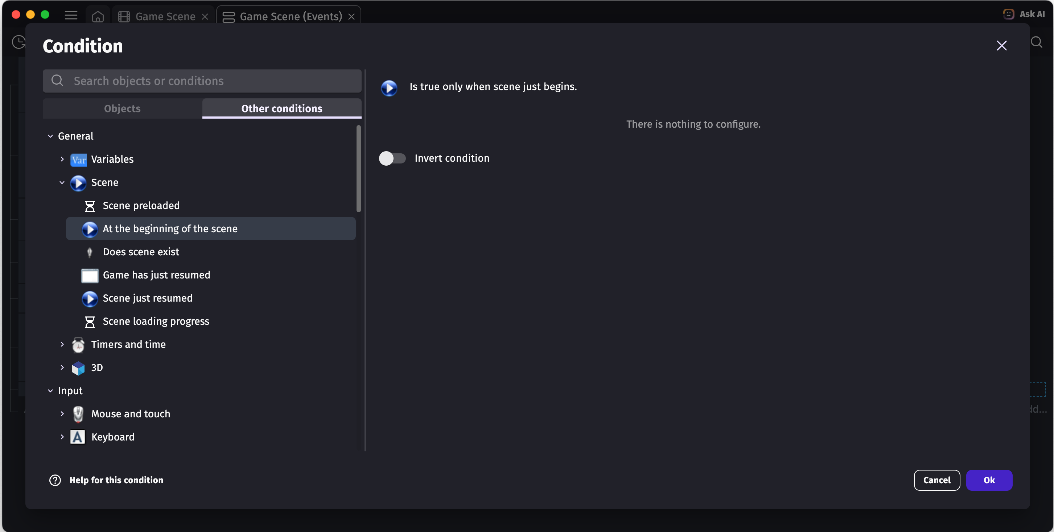
Now we can create a variable, where to store the information for where the player started. We can create a variable called something like “PlayerSpawn” which can be of type Array. You can create variables with the purple arrow button next to the variable name.
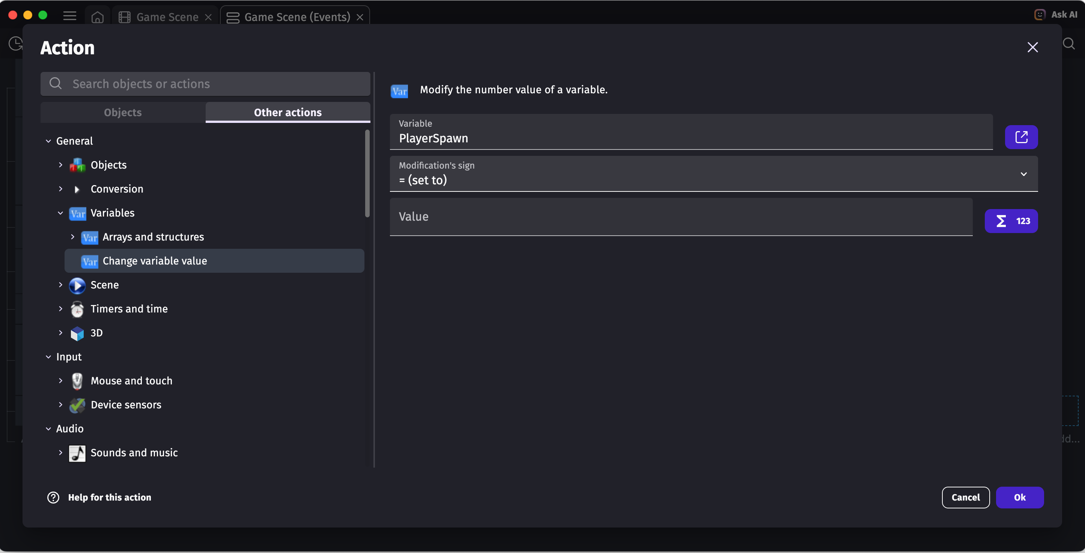
If you get stuck, don’t hesitate to ask for help!

Fall off-screen (continued)
You can then get the player position X and Y values and repeat for PlayerSpawn[1]
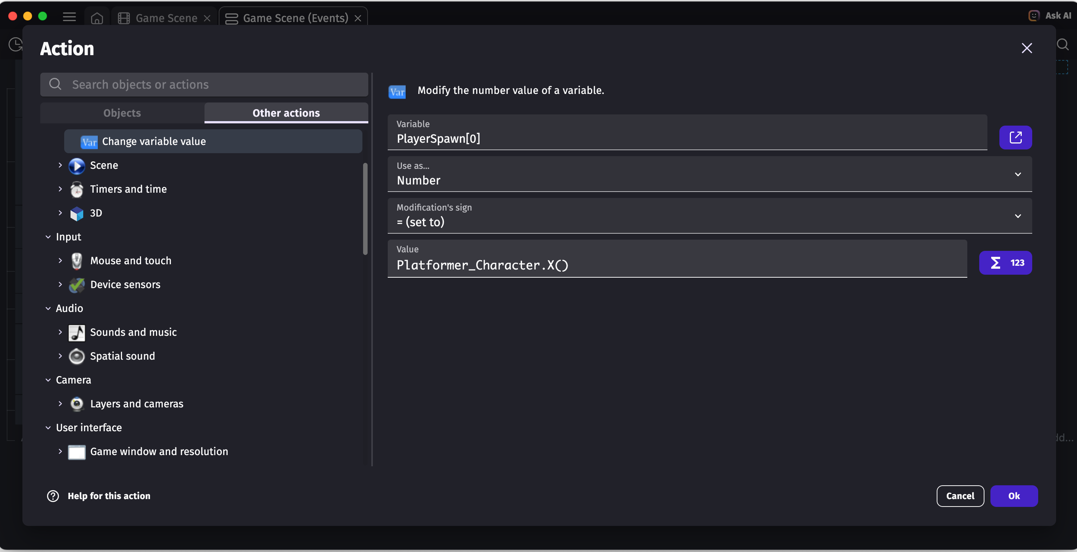
Now we can go back to the condition where the player falls of the screen (Y > 720) and set the player position to the PlayerSpawn variable, which will reset the player back to the start. And repeat for Y as a second action for PlayerSpawn[1] for the player’s Y position.
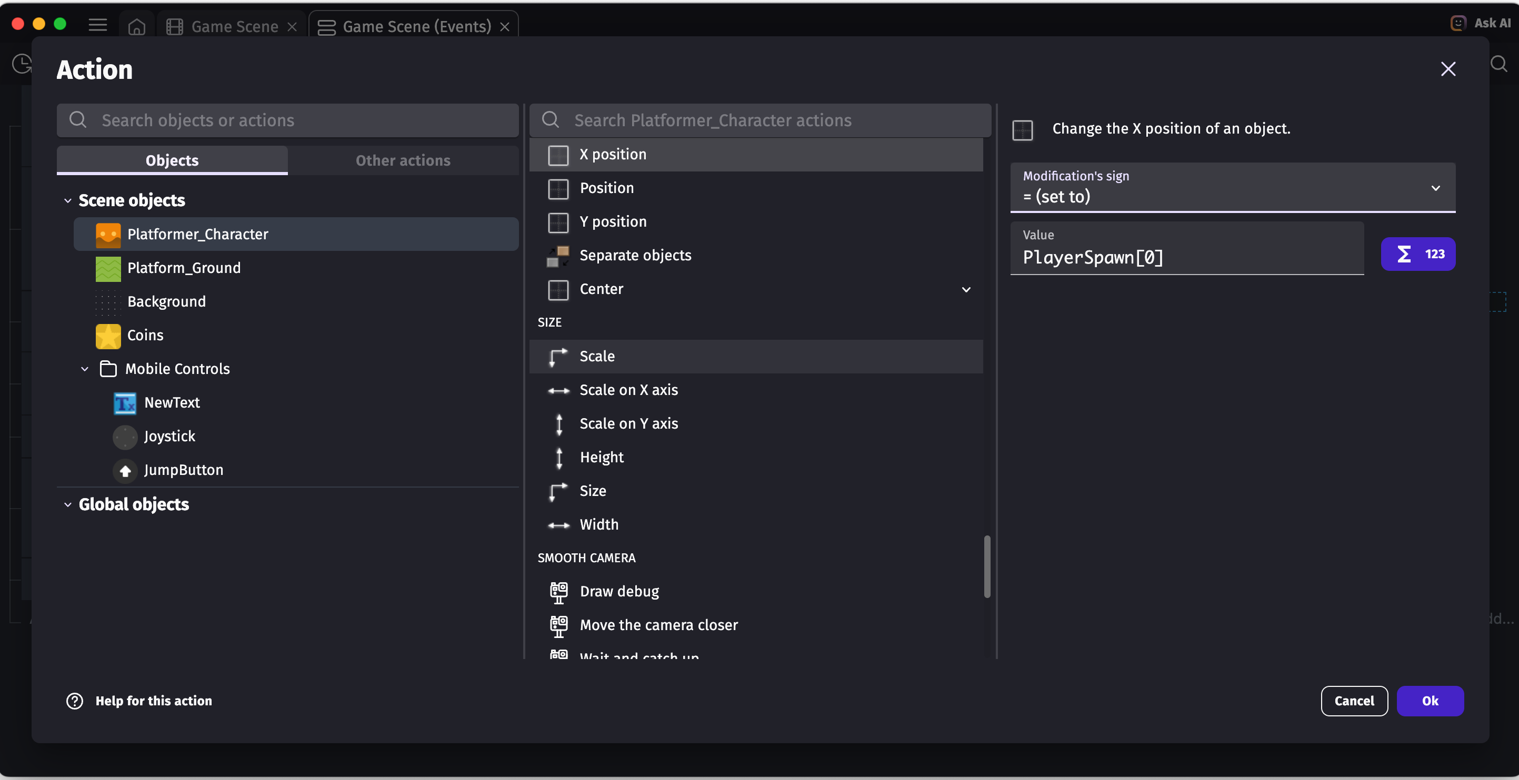

Keeping Score
The best way to add a score text to the screen is to make use of the Mobile Controls object. It’s always the same position on screen, so the score won’t move as the background moves. You can add a “Text” object to it.
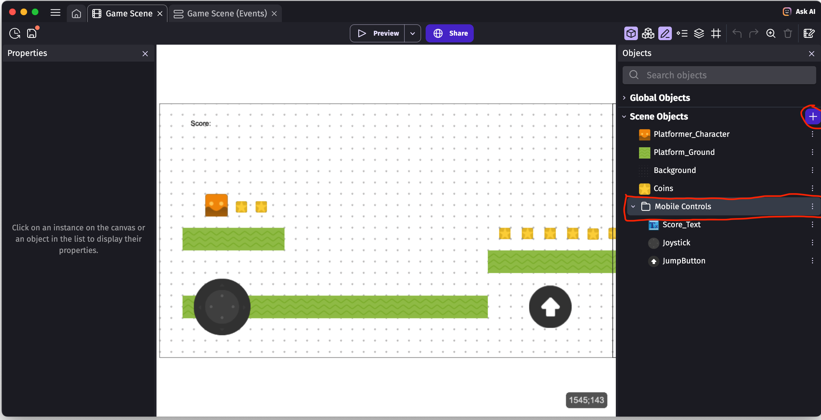
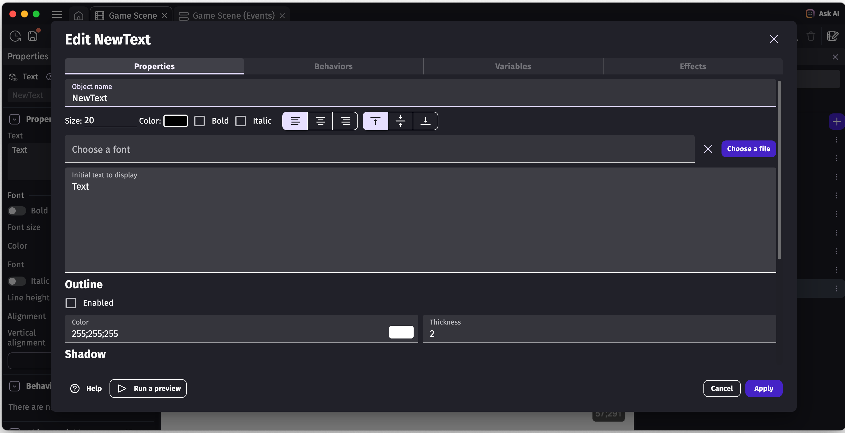

Keeping Score (continued)
Now to add the logic to make it update. Back in the game scene events, there should already be a condition for when the player collides with coins. The tricky part here is we want to first update a new variable “Score” and add one to it. You can recall how to create variables from the fall off-screen step.
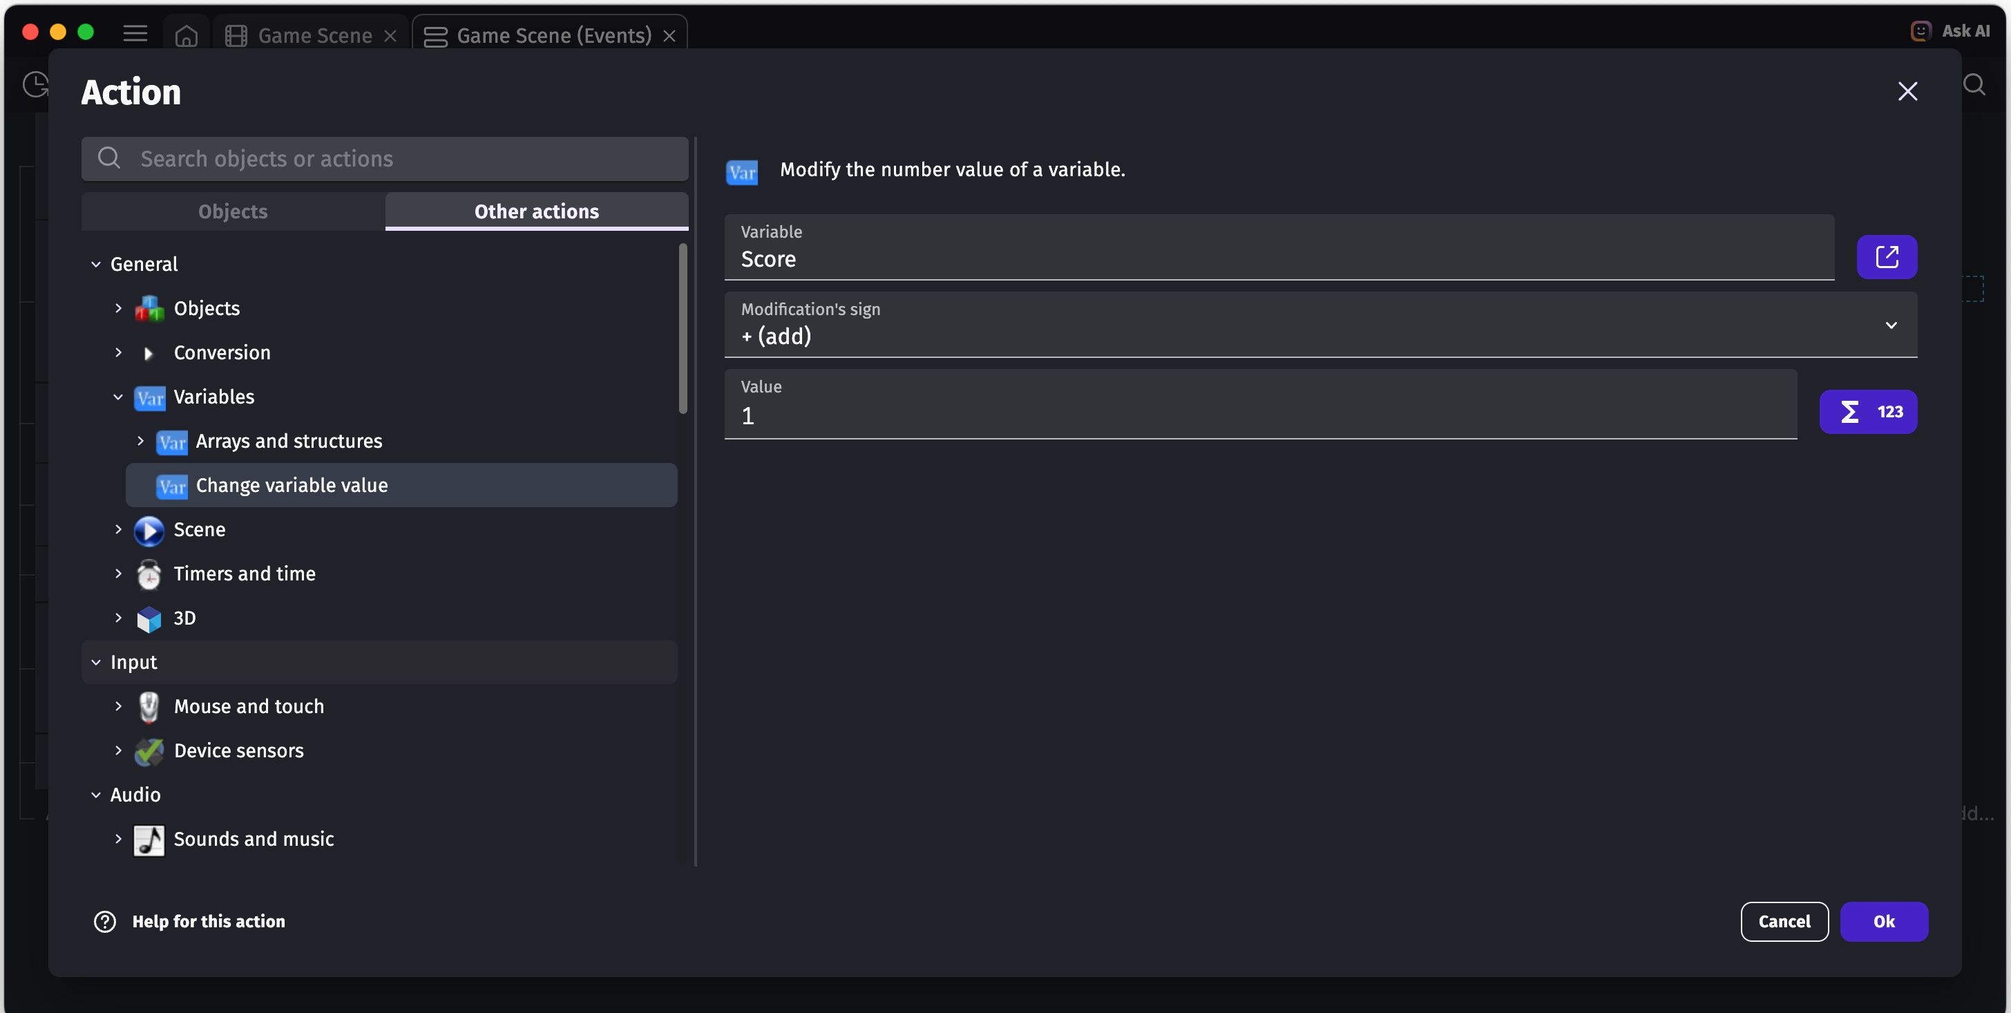
Then we want to set a new variable called “ScoreText” to the text “Score “ and then the score number. We can be clever and format the string to combine the text “Score” with the number.
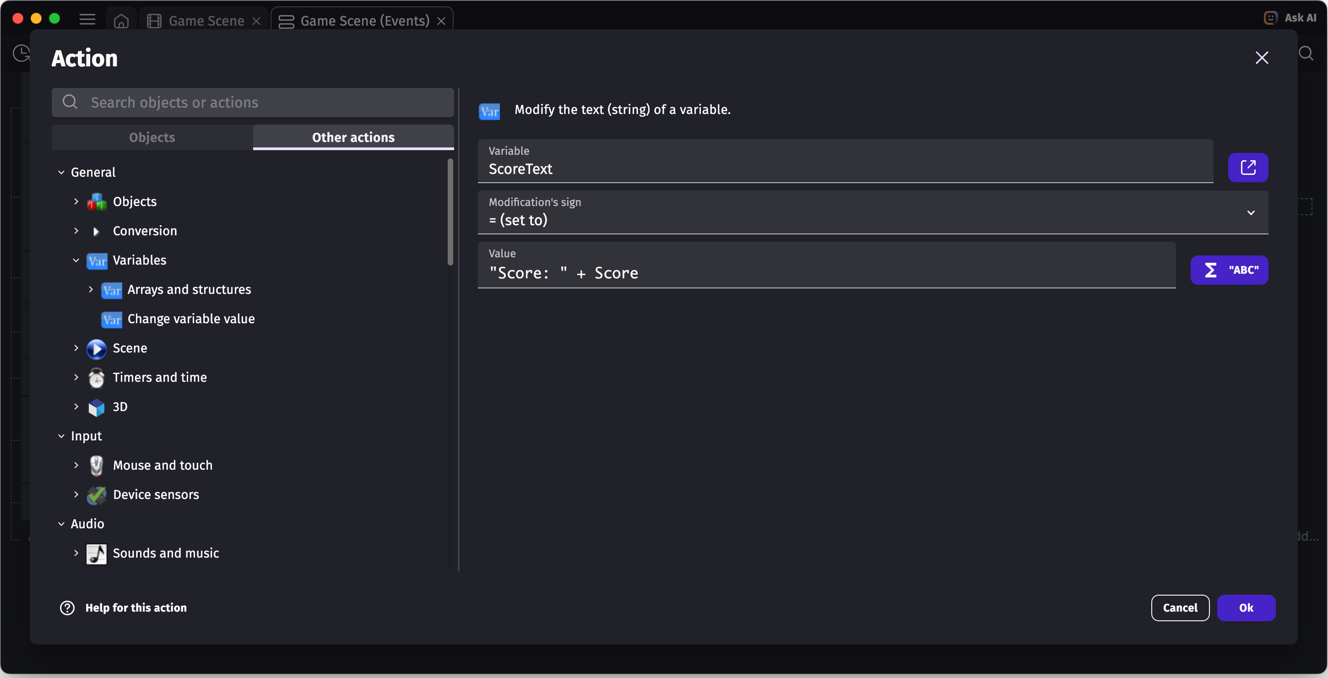

Keeping Score (continued)
Finally, we can set the actual score text game object to the string we created in the previous step.
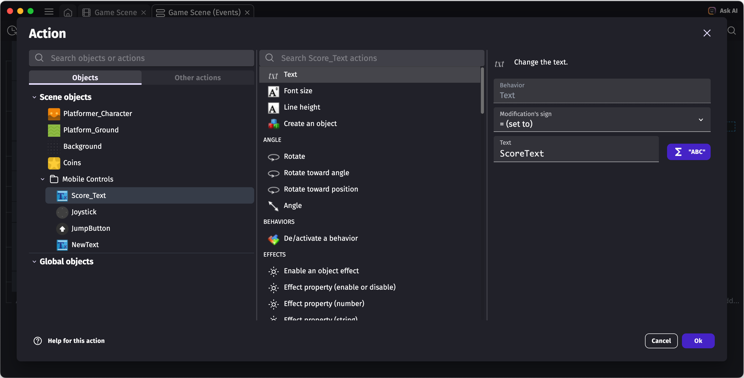
Now you can run the game with “Preview” and see the score update. Remember to save your work with the save icon on the top left.
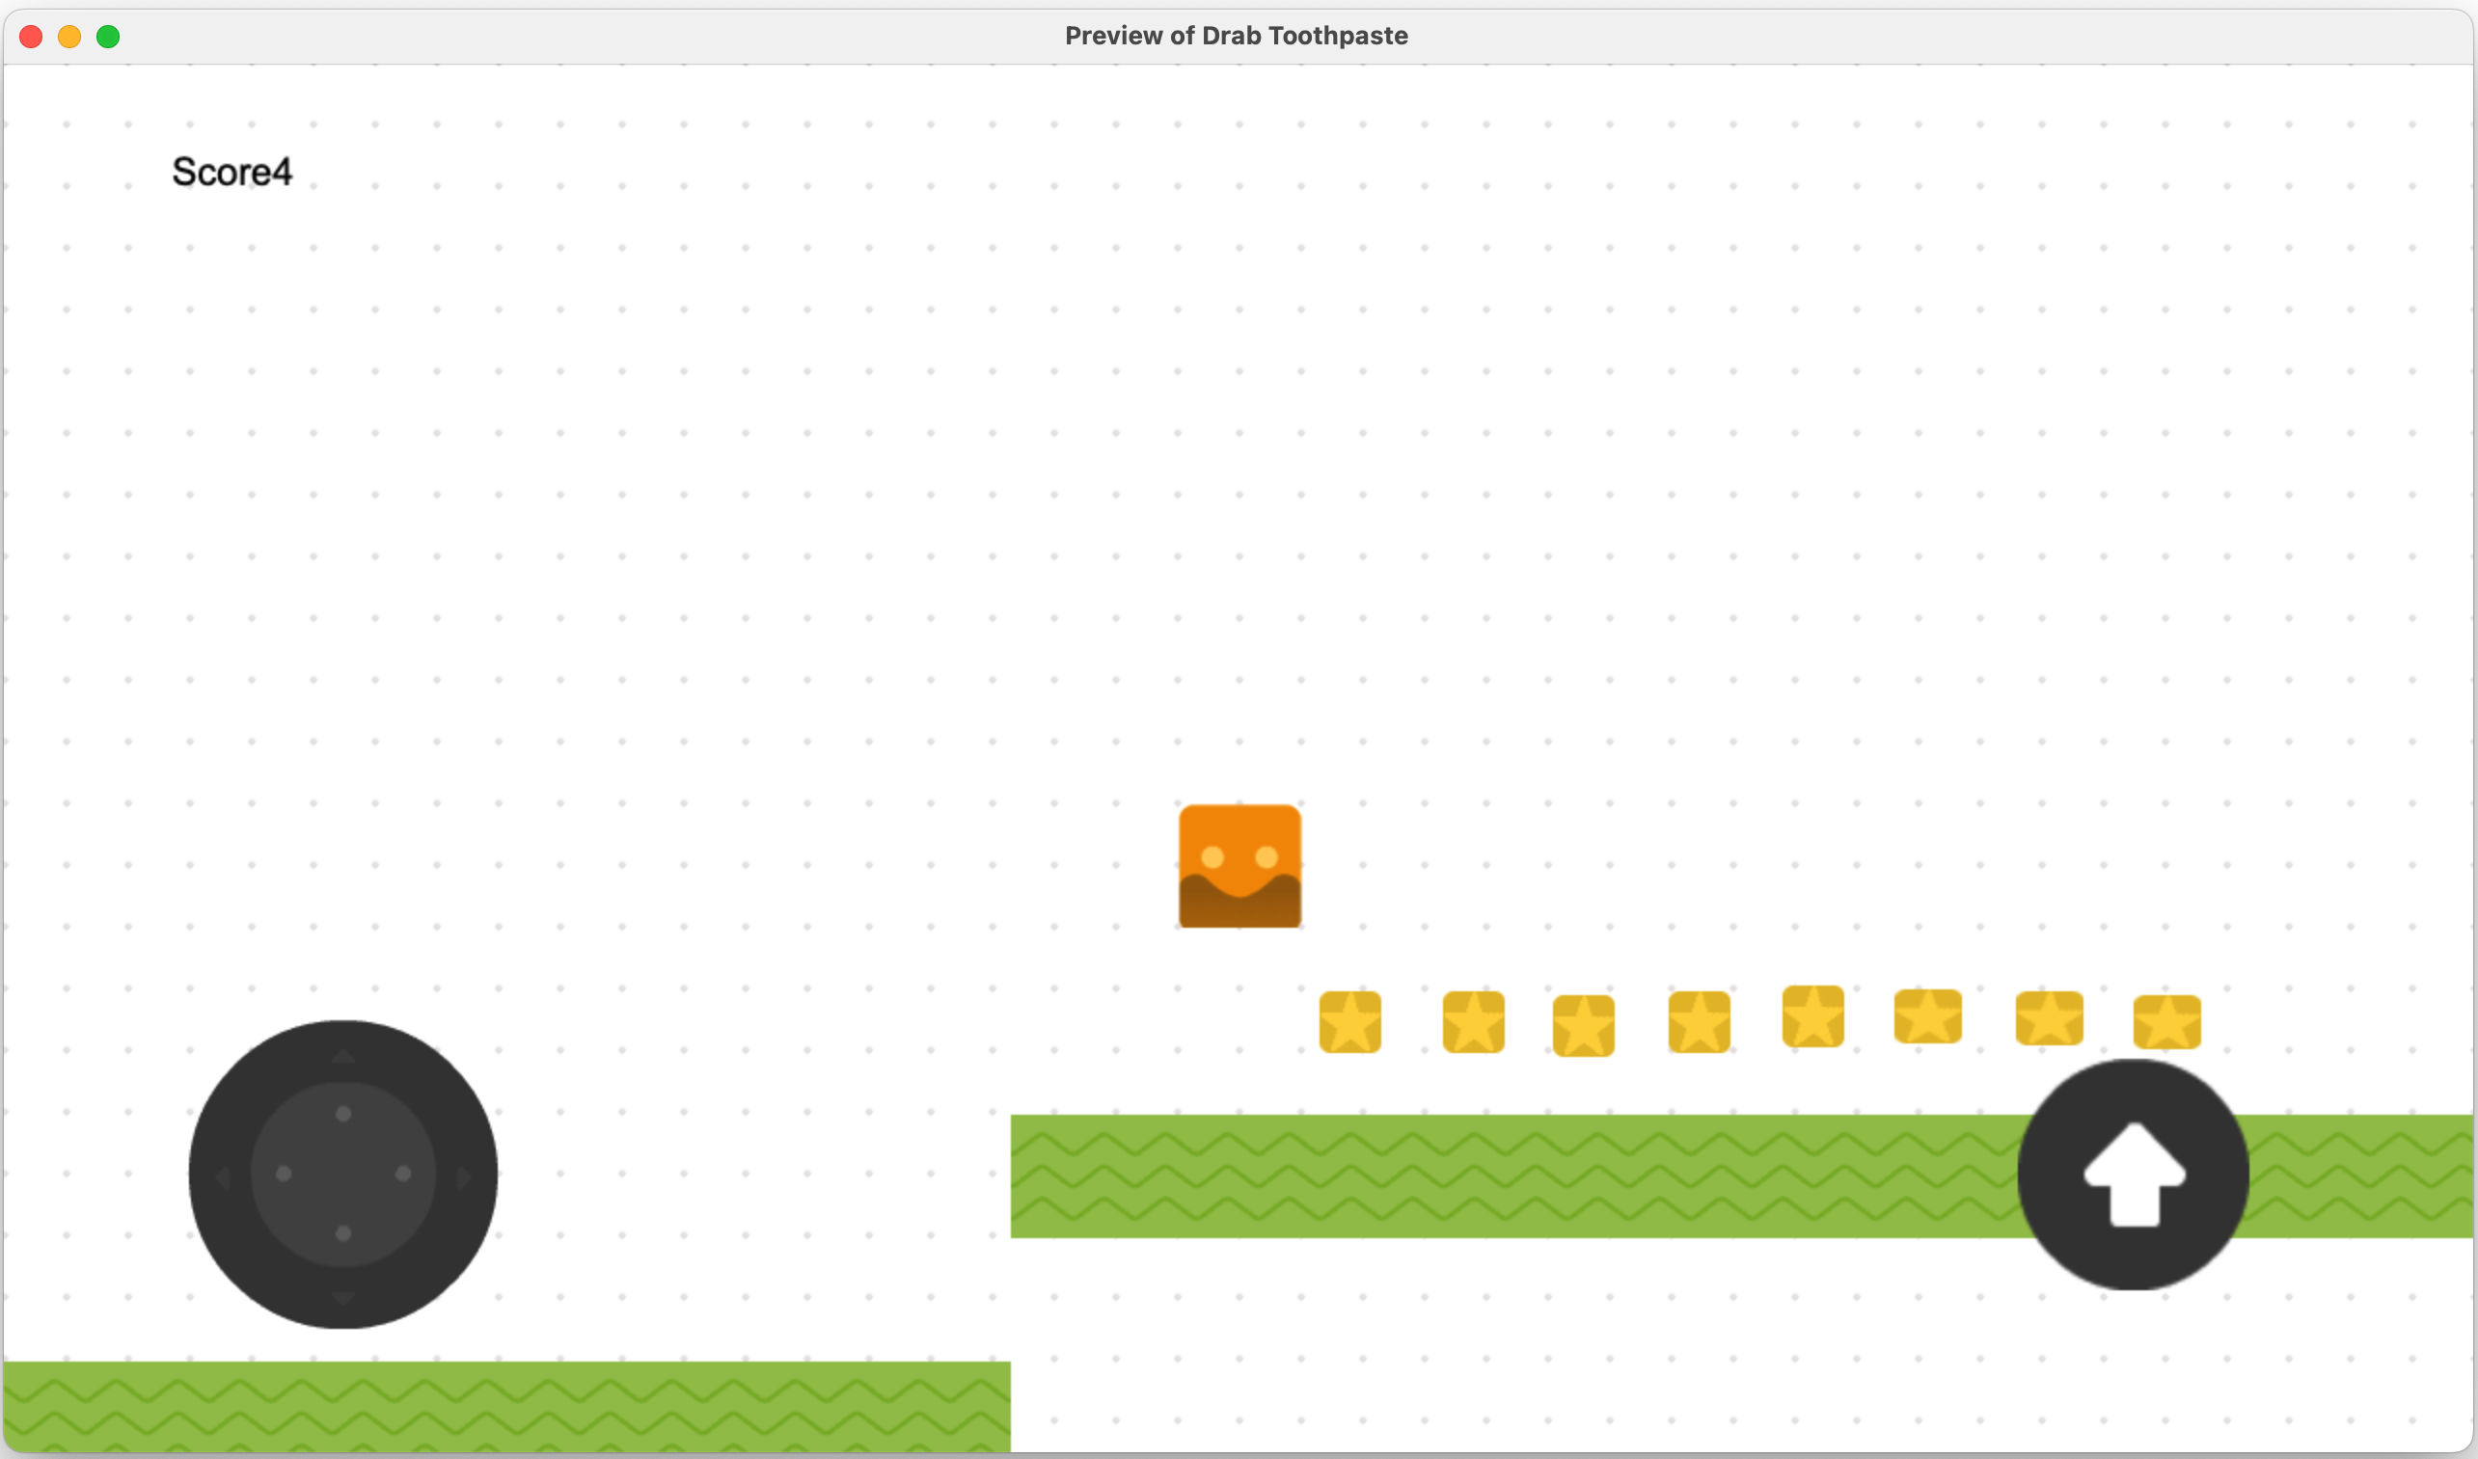

Win Condition
Most games have a win condition, or when the game ends or moves to the next level. We can add one! For example when you collect all of the coins. As before, we can add a new event, for example, we already keep track of the score. Like how we store the player position at the start, we can store the total number of coins on screen. In the “At the beginning of the scene” event, we can add a new variable such as “NumberCoins” and set it to Objects -> Number of Instances on the scene and type in “Coins”.
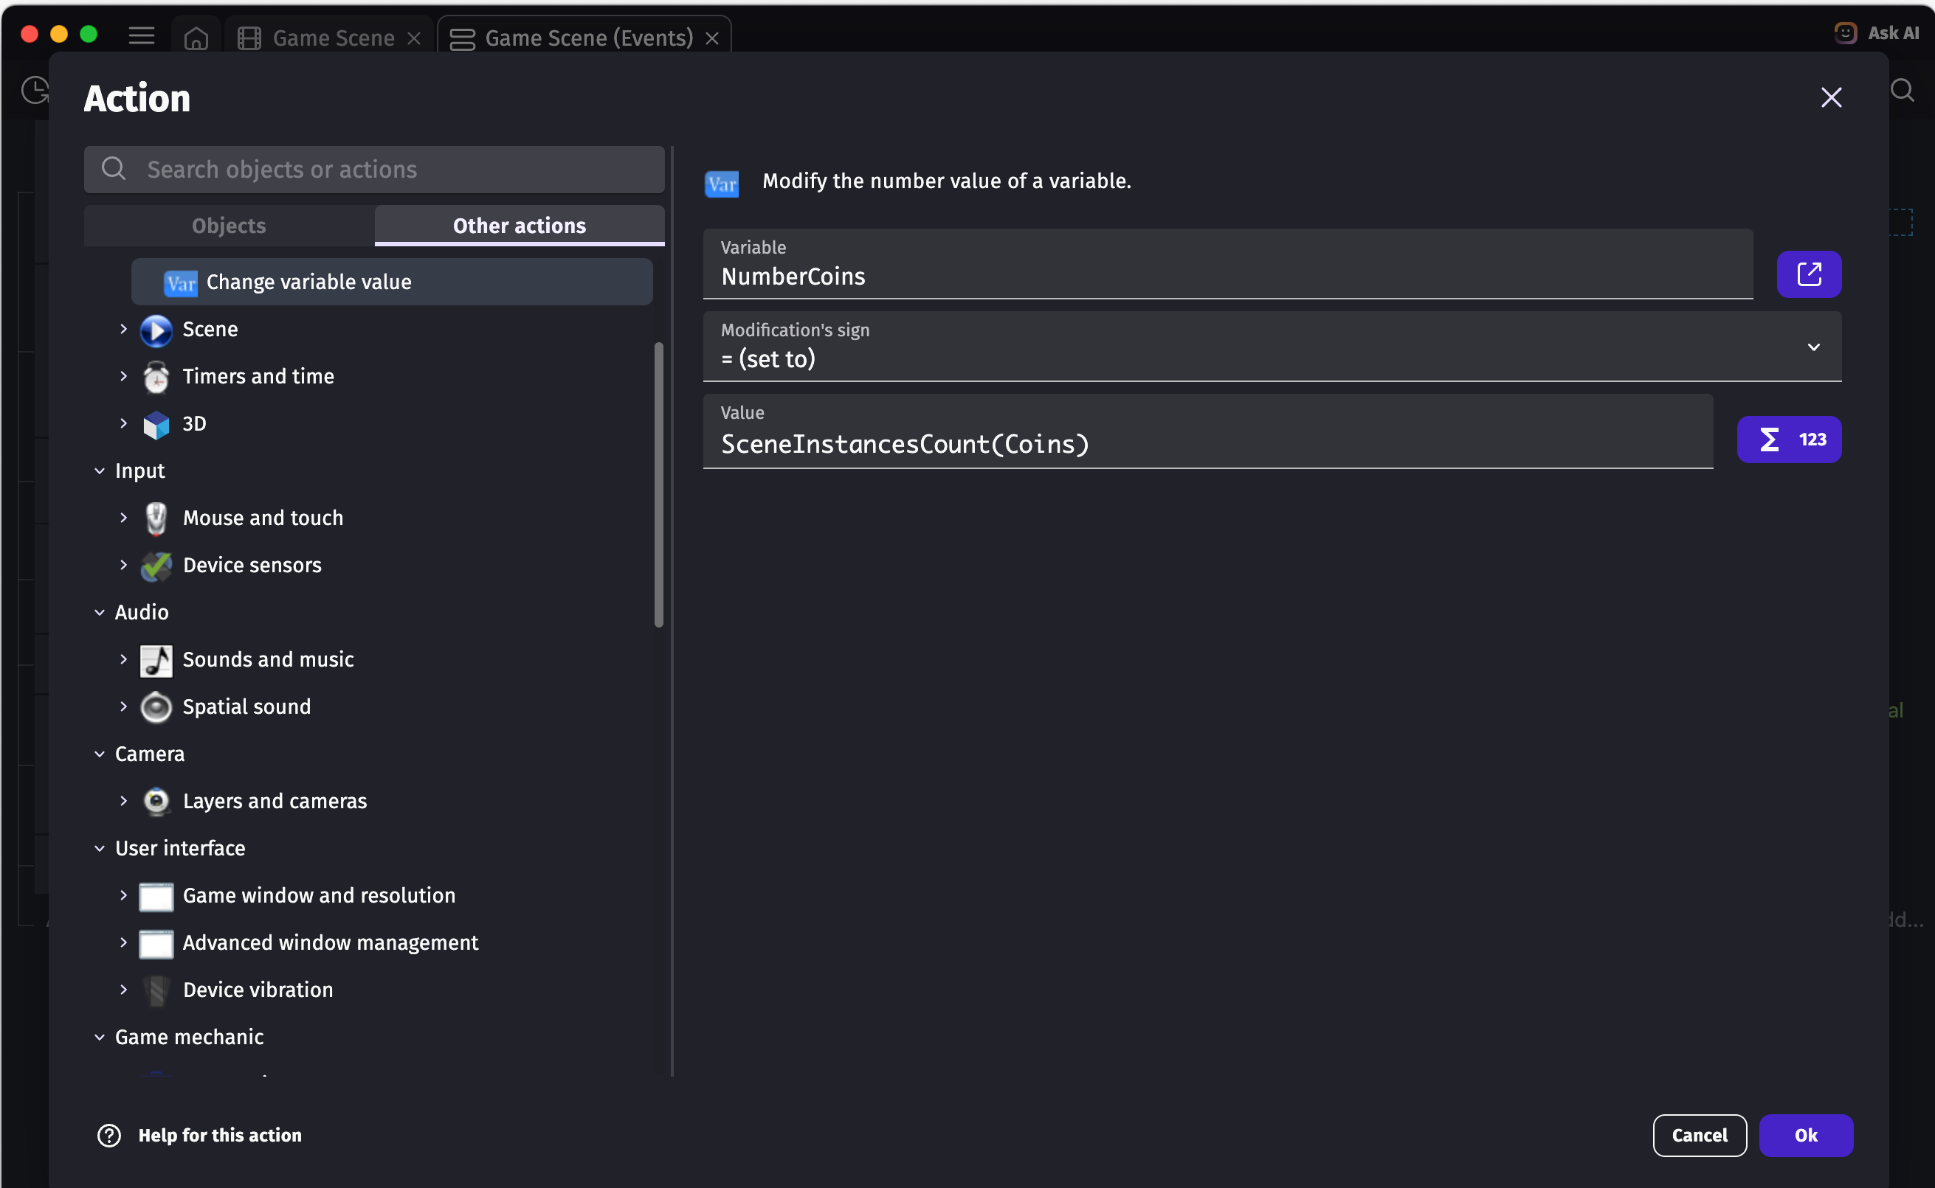
Then we can add an event for when the variable Score is greater or equal to NumberCoins
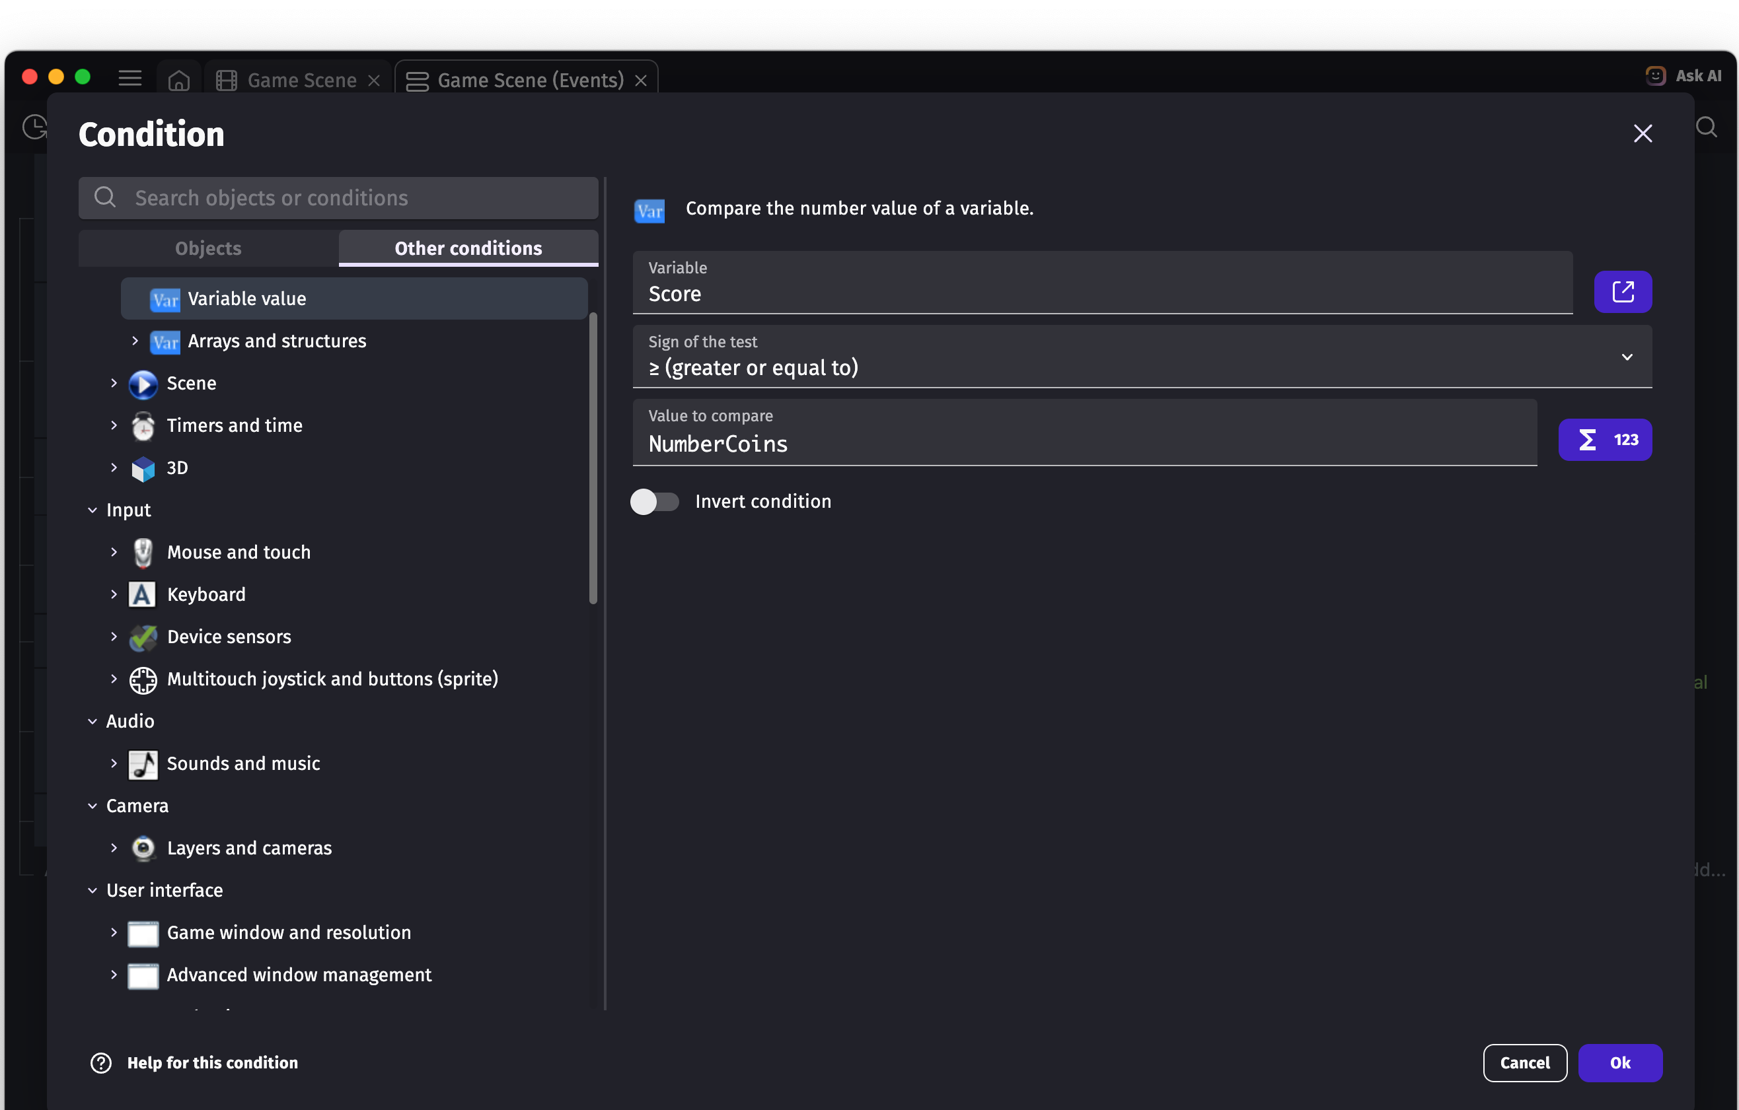

Win Conditions (continued)
From here, it’s up to you what to do when the win condition is triggered. I added a sound effect that plays, or you could display fireworks. GDevelop has an asset store, where you can get free and paid assets. I found a free “Fire spell” image which is an animated sprite. You could get something like that to display. This workshop is partly guided, but partly experimental, so it’s up to you to decide what to do with the rest of the game. Some examples are
- Add music
- Add a main menu
- Add a more interesting background
- Add a different player image

Sharing Your Game
Rememer to save your game! It is quite easy to share a game with the “Share” button at the top of the screen. The benefits of having an account are that you can share a link to a web page with you game. I recommend sharing your game to fellow workshop attendees and friends! Or even the Tas Game Makers Discord server if you feel like it!

Resources

Music and Audio
- https://musiclab.chromeexperiments.com/Song-Maker – make simple songs
- https://sfxr.me/ – retro sound effects
- Pixabay – royalty free audio and music
- https://www.musicmakerjam.app/ – App for iOS and Android – extra samples cost though

Images
- Inkscape – free vector image editor
- OpenGameArt – free and open source game art
- GIMP – another free image editor
- https://www.photopea.com/ – kinda similar to photoshop but free and on the web

See Also
Leo Febey Tech – https://leofebeytech.com.au
Motley Pixels – https://motleypixels.com (My game studio name)
Tas Game Makers – https://tasgamemakers.com (Tasmanian game makers community)

